4.4 Surface Area; Parametric Surfaces Worksheet

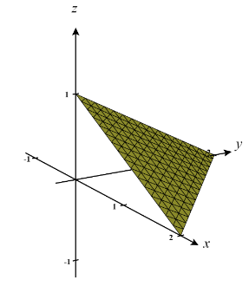
- Consider the surface given by which lies in the first octant. Determine the exact surface area of .

We are working with the surface shown at the right. We can see that we are working above the region D (shown in gray below). We can define D as

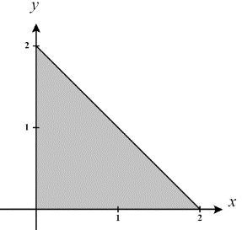
We are interested in finding the surface area of the surface determined by which lies above the region .

So, the surface area is given by the double integral:

- Consider the surface given by which lies below the plane . Determine the exact surface area of .

The equation intersects the plane and creates which is a circle of radius 3. Thus, we are interested in finding the surface area of the surface determined by which lies above .

So, the surface area is given by the double integral:

From the integral we see that it will be favorable if we change to polar coordinates.
We note that in polar . Then,

- Consider the surface determined by where and .
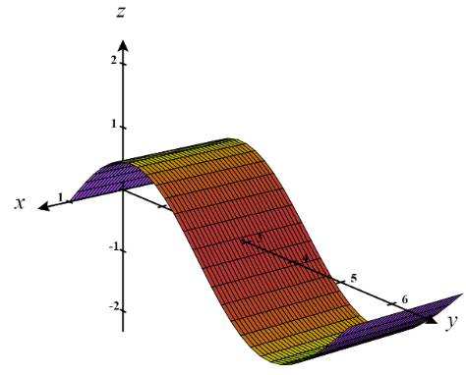
  - Set up an iterated integral which computes the surface area of this surface.

We are interested in finding the surface area of the surface determined by which lies above the region .

So, the surface area is given by the double integral:

  - Find a parameterization of the surface.

If we let then we can say that where and .
Therefore, the given surface can be parameterized as
for and .

  - Set up an iterated integral which computes the surface area of this parameterized surface.

We calculate that:
Therefore,
and thus,

Now, we have that,

- Consider the part of the graph where and .
  - Set up an iterated integral which computes the surface area of this surface.
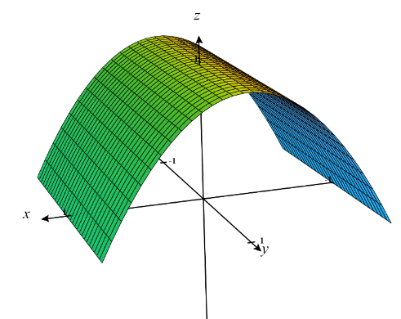
We are interested in finding the surface area of the surface determined by which lies above the region . Notice that since we have .

So, the surface area is given by the double integral:

  - Find a parameterization of the surface.

If we let then we can say that where and .
Therefore, the given surface can be parameterized as
for & .

  - Set up an iterated integral which computes the surface area of this parameterized surface.

We calculate that:
Therefore,
and thus,

Now, we have that,

- Consider the surface with the parameterization with and .
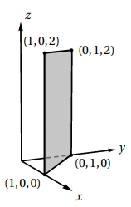
  - Sketch a picture of and determine its surface area algebraically.

We see that is just a rectangle in the first octant as shown in the picture at the right.

Clearly this rectangle has a height of 2 and a width of. Therefore, has a surface are of .

  - Set up an iterated integral which computes the surface area of and confirm that it evaluates to the surface area you found in part (a).

We calculate that:
Therefore,
and thus,
Now, we have that,
  - Can this surface be presented as a function ?

From the picture of we clearly see that cannot be written as a function in the form of . Very clearly for a single input of the surface has many points with different z-values.

- Consider the surface with the parameterization with and .
  - Sketch a picture of and describe its shape.
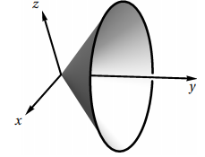
A picture of is shown at the right. This surface has the shape of a cone starting at the origin and opening down the y-axis.

  - Set up an iterated integral which computes the surface area of and calculate this integral.

We calculate that:
Therefore,
and thus,

Now, we have that,

  - Find a way to write express as two functions of the form

Since we are given that is represented by with and , we can then say that

This implies that .

So, we have that with . We can represent this as two functions with the following forms:
with
with
(These two formulas represent the “top” and “bottom” portions of the cone.)

  - Determine the surface area of using functions you found in part (c) and confirm that your result matches the result from part (b).

We are interested in finding the surface area of the surfaces determined by & which both lie above the region D which has the shape of a triangle as shown below.

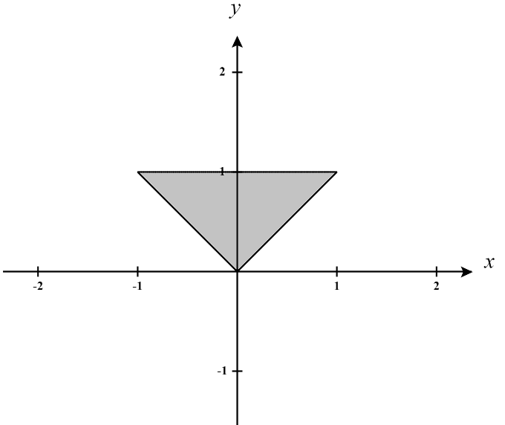

We can define this region as .

So, the surface area is given by:

Evaluating this integral by hand is a little tricky and requires a few algebraic manipulations in order to see the integrand as the derivative of an inverse sine function.

First we see that,

Therefore,

- Consider the surface parameterized by for ,
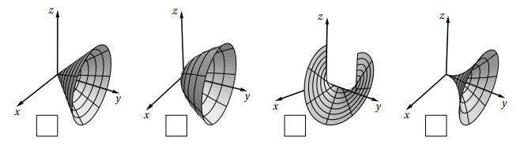
- Mark the box below which corresponds to the picture of .

Notice that we when projected to the xz-plane we have circles with radii growing quadratically.

- Set up an iterated integral which computes the surface area of .

We calculate that:
Therefore,
and thus,

Now, we have that,

- Consider the surface parameterized by for ,
- Mark the box below which corresponds to the picture of .
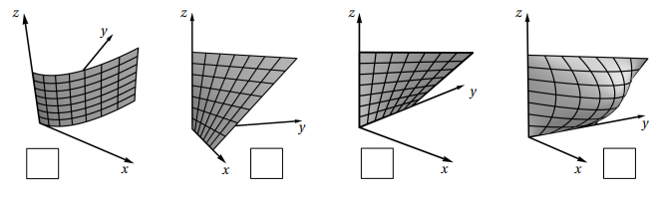

- Set up an iterated integral which computes the surface area of .

We calculate that:
Therefore,
and thus,

Now, we have that,

- Express as a function in terms of x, y, & z.

We can see that where .

- Consider a cylindrical can of radius 4 and a height of 5 (including top and bottom).
- Create a parameterization of these surfaces, you will need 3 parameterizations in total. Note: Infinitely many parameterizations exist.
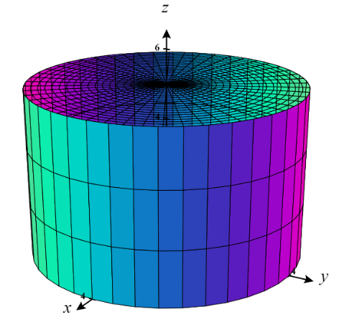
We can express the cylinder parametrically as for & .
We can then express the bottom of the can as for & .and the top of the can as for & .

- Set up iterated integrals to compute the surface area of each of the three surfaces from part (a) to determine the surface area of the entire can.

Surface area for :
We calculate that:
Therefore,
and thus,

Now, we have that,

Surface area for :
We calculate that:
Therefore,
and thus,

Now, we have that,

Surface area for :
We calculate that:
Therefore,
and thus,

Now, we have that,

Therefore, we can say that the surface area of the entire can is .

